

# KIET GROUP OF INSTITUTIONS

# GHAZIABAD

# **Project Synopsis on**

# **Online Auction System**

# **Master of computer Application (2023-24)**

# **Affiliated to**

Dr. A. P. J. Abdul Kalam Technical University, Lucknow

***Project Mentor Submitted By***

Ekansh Srivastava

Akash Singh

TABLE OF CONTENTS

|  |  |
| --- | --- |
| 1. | Introduction |
| 2. | Purpose |
| 3. | Solution |
| 4. | Objective |
| 5. | Basic Requirements H/W & S/W |
| 6. | Block Diagram & 0-Level DFD |
| 7. | Conclusion |

Introduction

The advent of the internet has revolutionized the way commerce operates, and one of the most remarkable manifestations of this digital transformation is the Online Auction System. This innovative platform has fundamentally reshaped the buying and selling landscape, transcending geographical boundaries and creating a dynamic marketplace accessible to anyone with an internet connection.

At its core, the online auction system offers an unparalleled opportunity for individuals and businesses to engage in trade on a global scale. Whether you're a seller looking to showcase your products to a vast and diverse audience or a bidder searching for unique items or competitive deals, this system provides an inclusive and efficient environment for both parties.

In this interconnected world, the concept of "global reach" takes center stage. The online auction system empowers sellers to connect with potential customers from different corners of the world, offering their wares to a broader and more diverse market. Simultaneously, it enables bidders to explore a vast array of products and services, transcending the limitations of physical proximity.

Throughout this exploration, transparency and trust play pivotal roles. The system's architecture ensures that participants can view real-time bid updates, track auctions, and provide feedback, fostering an environment of integrity and accountability.

This introduction sets the stage for a comprehensive exploration of the online auction system, delving into its features, benefits, and impact on modern commerce. As technology continues to evolve, this system remains a dynamic force, shaping the future of e-commerce and opening new horizons for businesses and consumers alike.

Top of Form

Purpose

The purpose of an online auction system is to provide a platform that facilitates the buying and selling of various products through an online bidding process. This system serves the needs of both sellers and bidders, creating a virtual marketplace where items are auctioned to the highest bidder. The key purposes of an online auction system include:

Efficient Buying and Selling: To offer a convenient and efficient way for individuals and businesses to sell their products to a wide audience and for buyers to acquire desired items.

Price Discovery: To enable sellers to discover the market value of their products through competitive bidding, ensuring fair prices based on supply and demand.

Global Reach: To extend the reach of sellers beyond their local markets, connecting them with potential buyers from around the world.

Convenience: To provide a convenient and accessible platform where users can participate in auctions from the comfort of their homes or offices, eliminating geographical constraints.

Transparency: To maintain transparency in the bidding process, allowing users to see the current highest bid and the remaining time for bidding.

Feedback Mechanism: To collect and display user feedback, promoting trust and accountability among participants.

Solution

To achieve these purposes, an effective online auction system must offer a comprehensive solution that encompasses various features and functionalities. Here's a breakdown of the solution:

User Registration and Authentication:

Users can register with their personal information, creating secure accounts with unique credentials.

Product Listing:

Sellers can create detailed product listings, including descriptions, images, categories, starting bid prices, and auction durations.

Auction Mechanism:

Implement a bidding system that allows users to place bids on products within specified auction timeframes.

Automatically close auctions when time elapses and declare the highest bidder as the winner.

User Roles:

Define roles such as Sellers, Bidders, and Admin for efficient platform management.

Admin Panel:

Admin can oversee and moderate the entire system, including user accounts and product listings.

Security and Privacy:

Implement robust security measures to protect user data and transactions, ensuring privacy and data integrity.

Objective of project

The objective of the online auction system project is to create a robust and user-friendly platform that enables users to buy and sell items through online auctions. This platform aims to

[1] Facilitate Online Auctions: Provide a digital marketplace where individuals and businesses can easily list items for auction and participate in bidding processes, eliminating geographical constraints.

[2] User-Friendly Interface: Develop an intuitive and user-friendly website/application interface that allows users to navigate auctions, place bids, and manage their auction-related activities with ease.

[3] Feedback and Rating System: The introduction of a feedback and rating system allows users to share their auction experiences, fostering transparency and trust.

[4] User Login: User can register online and then access the system on authentication.

[5] Sort Products: User can sort products by category and price range.

[6] Global Reach: To extend the reach of sellers beyond their local markets, connecting them with potential buyers from around the world.

**Basics need of Hardware and Software**

**Software Requirements:**

* + Operating System: windows 8 or Higher
  + Vs Code, Xampp Server

**Hardware Components:**

* + Processor – i3
  + Hard Disk – 500 GB
  + Memory – 8GB RAM

Block Diagram

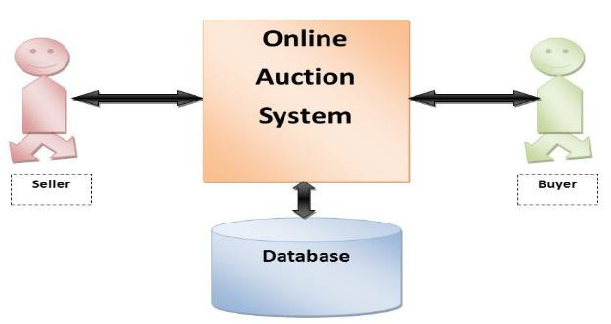

0 Level DFD

Seller

Database

Admin

Buyer

Conclusion

In conclusion, the online auction system represents a dynamic and transformative platform that has redefined the way people buy and sell products in the digital age. This innovative system has successfully addressed the challenges of traditional auctions, breaking down geographical constraints and ushering in a new era of global commerce.

One of its paramount achievements is its ability to provide a level playing field for sellers and buyers alike. Sellers can showcase their products to a vast and diverse global audience, reaching potential customers they could never have accessed through conventional means. The competitive bidding process ensures fair market prices, benefiting both sellers and buyers by facilitating price discovery.

Moreover, the online auction system fosters transparency and trust in transactions. Participants can view real-time bid updates and monitor auctions from the comfort of their homes or offices, enhancing convenience. The feedback mechanism further promotes accountability and builds a reputation system, assuring users of the platform's reliability.

Admin oversight, stringent security measures, and integrated payment solutions contribute to the system's robustness. It not only expands economic opportunities but also embraces the principles of accessibility, inclusivity, and convenience, making it a valuable asset in the digital economy.

As technology continues to evolve, the online auction system will likely play an increasingly pivotal role in shaping the future of e-commerce. Its ability to connect individuals and businesses worldwide while promoting fair competition and transparency positions it as a cornerstone of modern global trade.